Table of Contents

1 Workshop Progress Report Week One 2

1.1 In –depth Analysis of the Proposed Case Management System 2

1.1.1 Overview of the proposed CMS 3

1.1.2 Database Schema & Design 3

1.1.3 User Reports 3

1.1.4 User Management Module 4

1.1.5 Case Registration 4

1.1.6 Case Activities 4

1.1.7 E-Filing 4

1.1.8 Integration with Client Access Functions 5

1.2 System Development & Integration 5

1.2.1 User Reports Portal Screenshots 5

1.2.2 User Management Module 6

1.2.3 Login and Forget Password Screenshot 7

1.2.4 Dashboard Screenshot 9

1.2.5 Case Registration 9

1.2.6 USER MANAGEMENT 10

1.3 Court division page, which allows edit, delete or add; 19

1.3.2 Case Details 21

1.3.3 User Management Appendix 23

1.3.4 Database Schema Appendix 27

# Workshop Progress Report Week One

The following activities took place in the week one of the workshop

* In-depth Analysis of the Proposed Case Management System
* Development of User Interface, User management module, Database Schema & Case Registration Forms

## In –depth Analysis of the Proposed Case Management System

The proposed case management system was explored end to end, System modules were studied intensely and how the actual implementation will be done and integrated

The following presentations was made in regard to the analysis of the various component of the CMS

* Overview of the proposed CMS
* Database Schema & Design
* User Reports
* User management Module
* Case registration
* Case Activities
* E-Diary
* E-filing
* Court fee management
* Exhibit Management
* Integration of Client Access Functions

### Overview of the proposed CMS

The power point presentation was prepared by Ag. Director ICT was presented on behalf by Geoffrey, The presentation highlighted the following points:

* **ICMS ( Integrated Court Management System)** - All the ICT systems within the judiciary are integrated and work together seamlessly
* **Components of ICMS**- The Various components of the ICMS were Identified
* **Case Management System** Modules - The various components of Case Management system were identified
* **Approval by ICMS Committee** - The Role of ICMS Committee noted
* **SDLC Compliance** – The development of Case Management System to adopt SDLC Methodology
* **Deliverables of the Workshop** – The TORS ,Objectives and Deliverables of the workshop were Noted

### Database Schema & Design

Benson, made a presentation the proposed Database schema, a few changes were suggested and subsequently adopted.

The following facts were also noted

* The Database implementation will adopt **RDBMS** structure
* Database Technology will be **MSQL**

### User Reports

Benson, Made demonstration using the proposed DB we can be able to generate the following Reports: (Cause List, DCRT, Case load and other ad hoc Reports) at the DB level using the SQL queries

Benson & Patrick was tasked to Design a Report Portal for Case Management where all the user Reports can be accessed and generated and the Reports should be neatly formatted

### User Management Module

A presentation was done by Chelule how to manage the system users, user permissions and access rights.

The concept of Role Based User management was adopted there was also a demonstration of various technologies plugins used in user Management

Chelule was tasked design the User management Module

### Case Registration

The modality how to implement Case Registration was deliberated, the various fields required in case Registration form were identified and also the field unique to specific cases were also identified

Hellen & Chelule were apportioned the task to develop all the forms to be used in case registration

### Case Activities

An analysis was done on Case Activities, the modality on how capture case activities, track, Report and Send notifications were discussed and the implementation strategy established

The following aspects of Case Activities were also discussed: e-diary, exhibit management, court fee management

Ivy was tasked to design all the user forms that touch on Case Activities

### E-Filing

A detailed presentation was done by Ernest on e-filing implementation the various .The Team came up with various propositions on the implementation of the e-filing

* Issuance of practice direction to the Advocates
* Specialized officers to handle e-filing internally
* Need for electronic Payment gateway i.e API
* ICT Infrastructure preparedness

Ernest was tasked to champion the development and implementation of the electronic filing module.

### Integration with Client Access Functions

A presentation was done by Hellen on how Case Management System should provide a platform for the public and Advocates to access court information and also allow remote retrieving of case information via Information Kiosk, USSD application, android and IOS applications and web

Patrick & Hellen were tasked to champion the development and actual implementation of the integrations with client access points such as Information Kiosk, USSD application, android and IOS applications

## System Development & Integration

SDLC approach and standards will be adopted throughout the development of the Case Management System

The following development have been done so far and .The developed modules will be fine-tuned, extensively tested and perfected as development progresses

### User Reports Portal Screenshots

Generation of Cause List, Generated for individual court station/Division.

The cause list generated will be for an individual judicial officer or For all the Judicial officers in the station or Division

This are populated from a view created from the Database

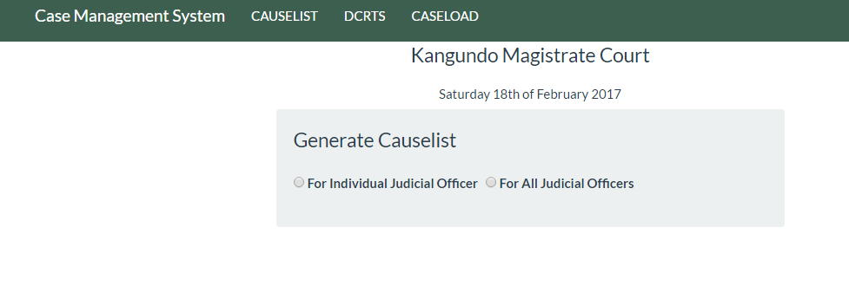

Can be for a specific Judicial Officer or for all the judicial officers in that station

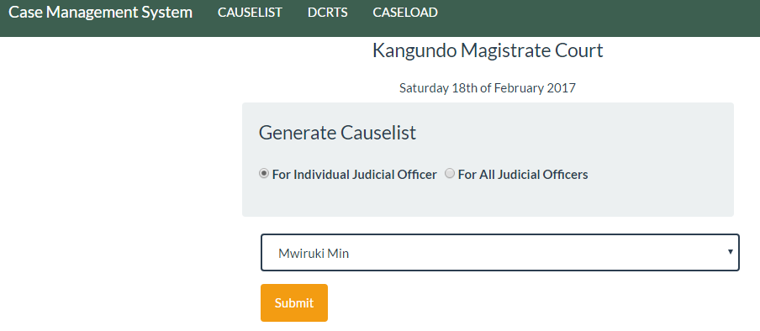

Result for one judicial officer

### User Management Module

This module is the foundational module for the system it provides the platform how users will be interacting with the system and all activities that entail system user management, Users have different permissions and access levels depending on their roles and the work they do

### Login and Forget Password Screenshot

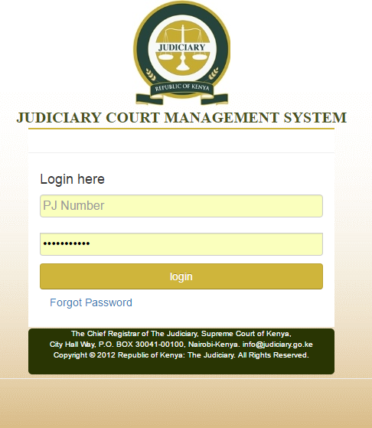

#### Login page

Use either PJ number or email address

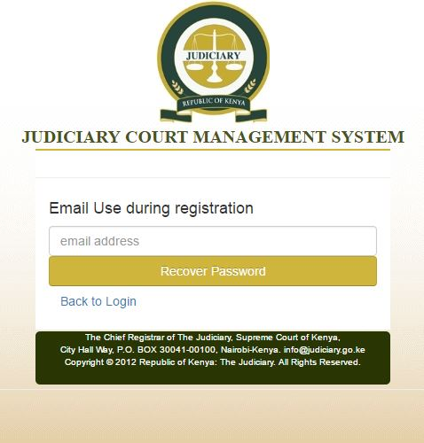

#### Forget password page. Requires a valid email that was used in the registration

### Dashboard Screenshot

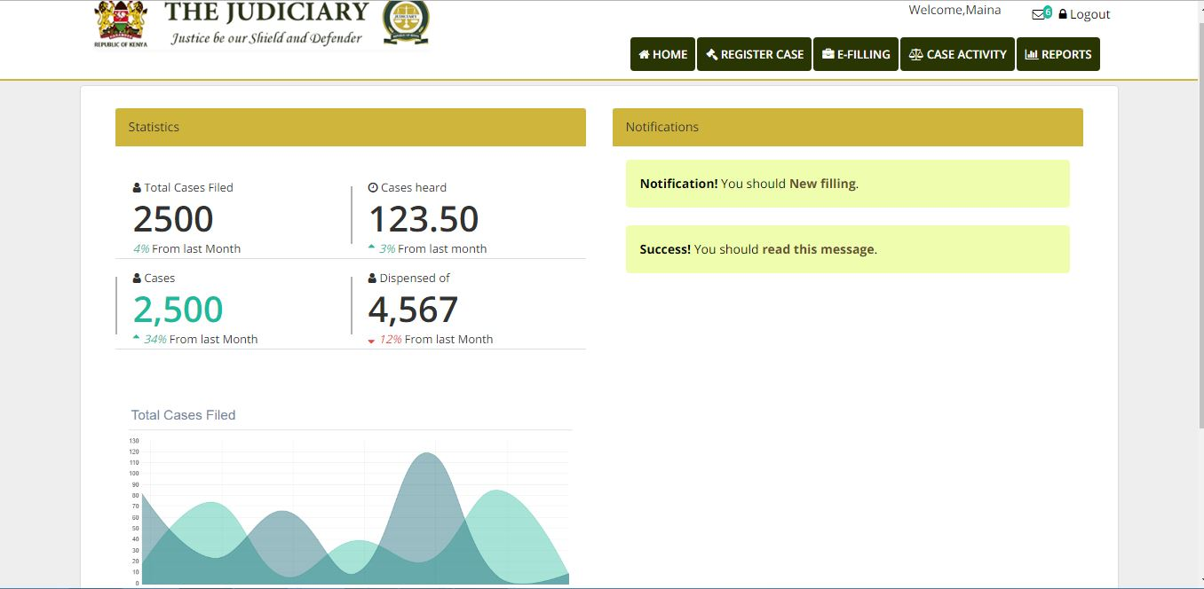

Dashboard pages that show all the:

1. Notifications
2. Case statistics

### Case Registration

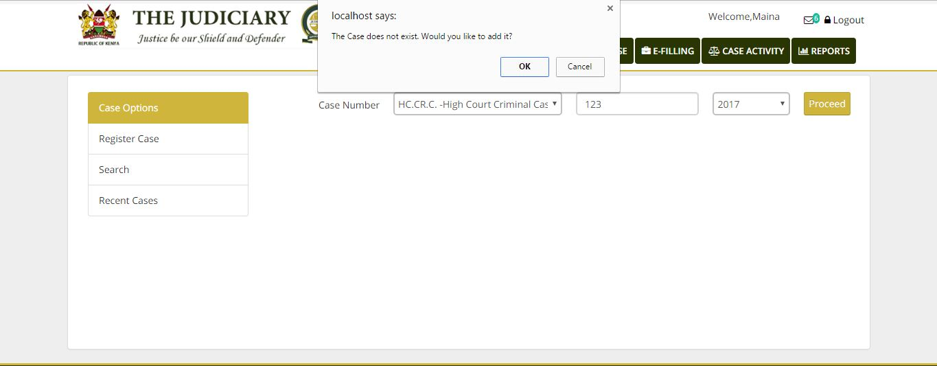

#### Search case for using case number.

Ensure that the case exist before registering. Help eliminate duplicated during data entry

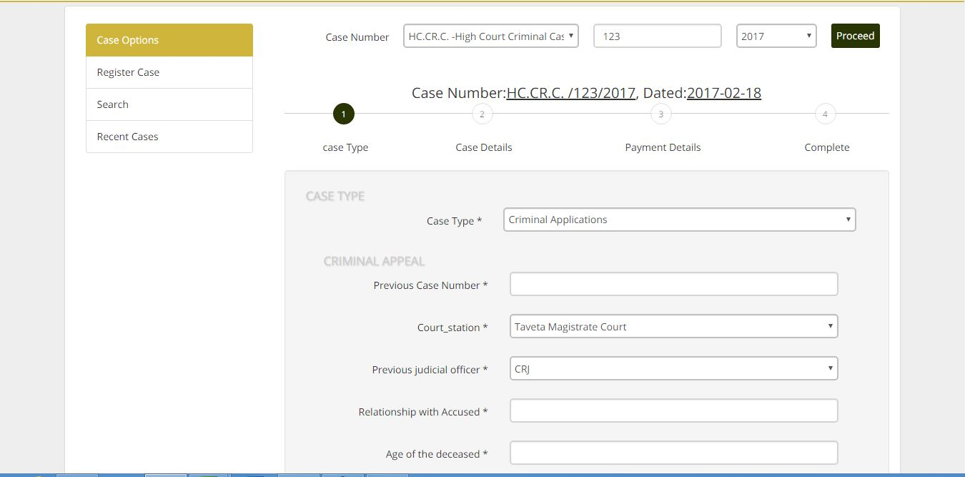

### USER MANAGEMENT

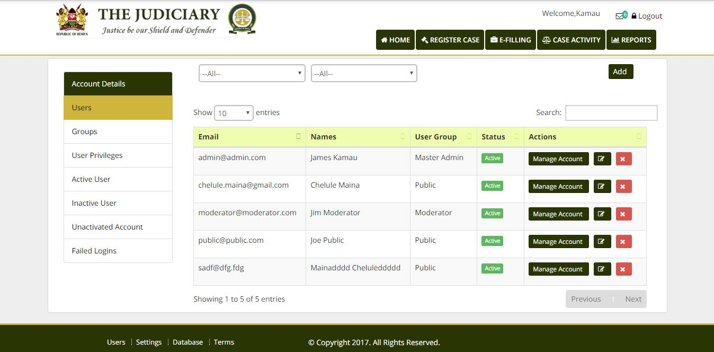

Add user

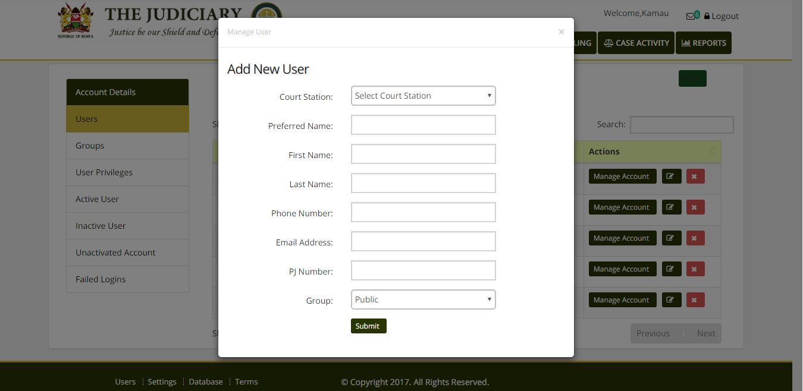

#### Add user page

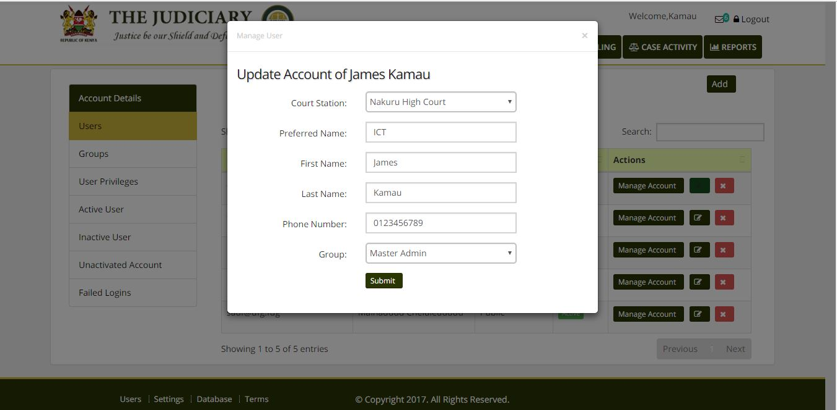

Edit user page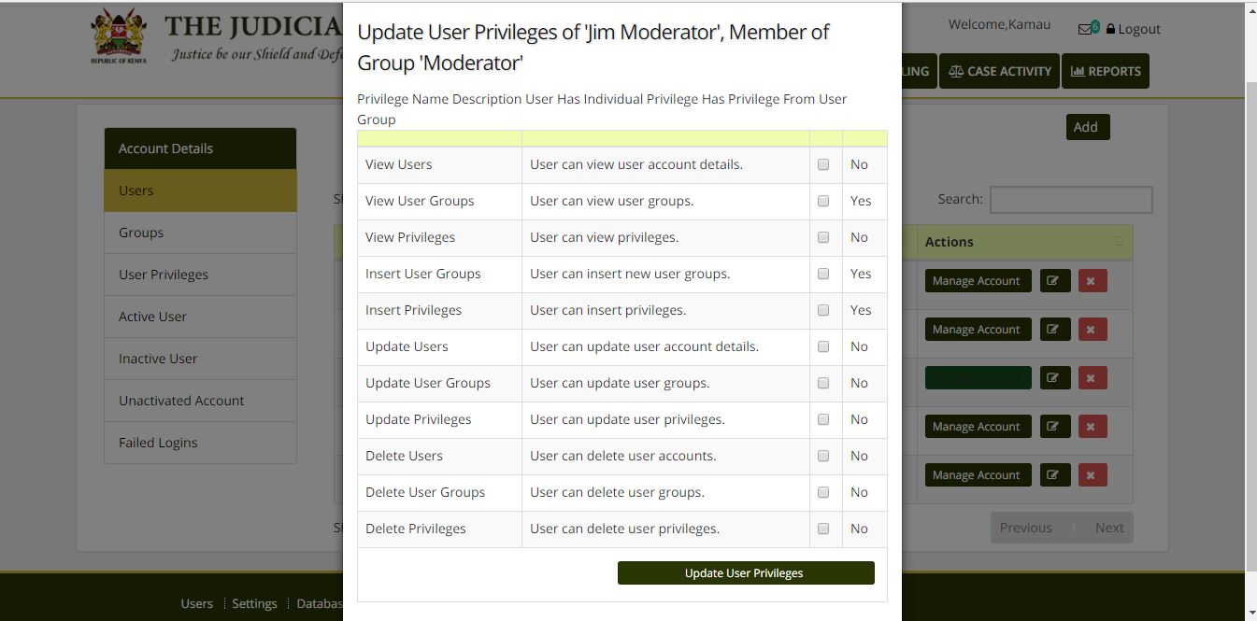

#### Manage user privileges

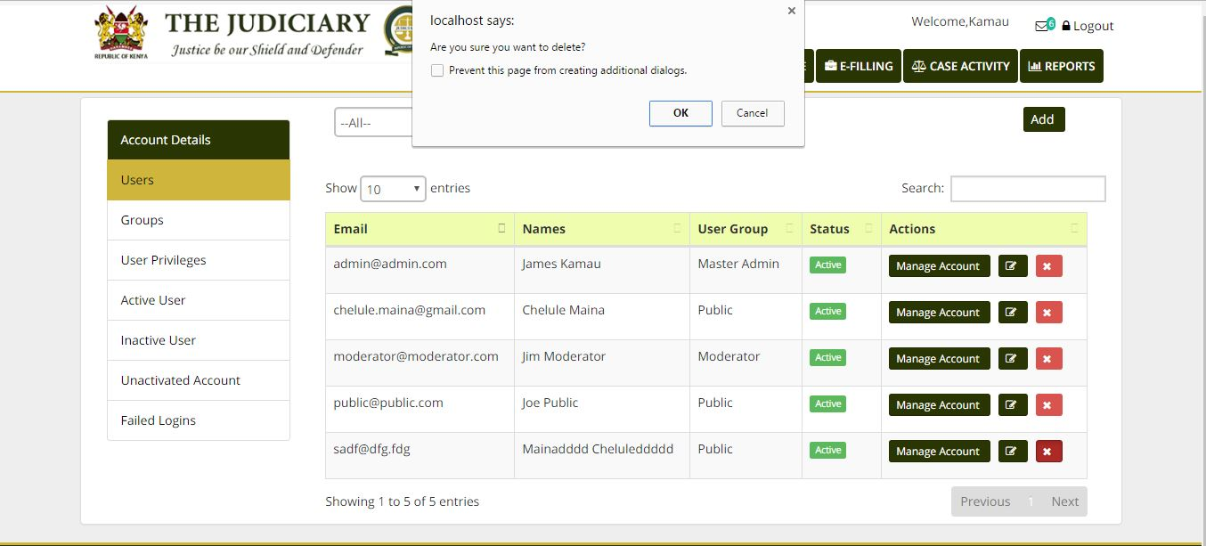

#### Suspend account

#### GROUPS PRIVILEGES

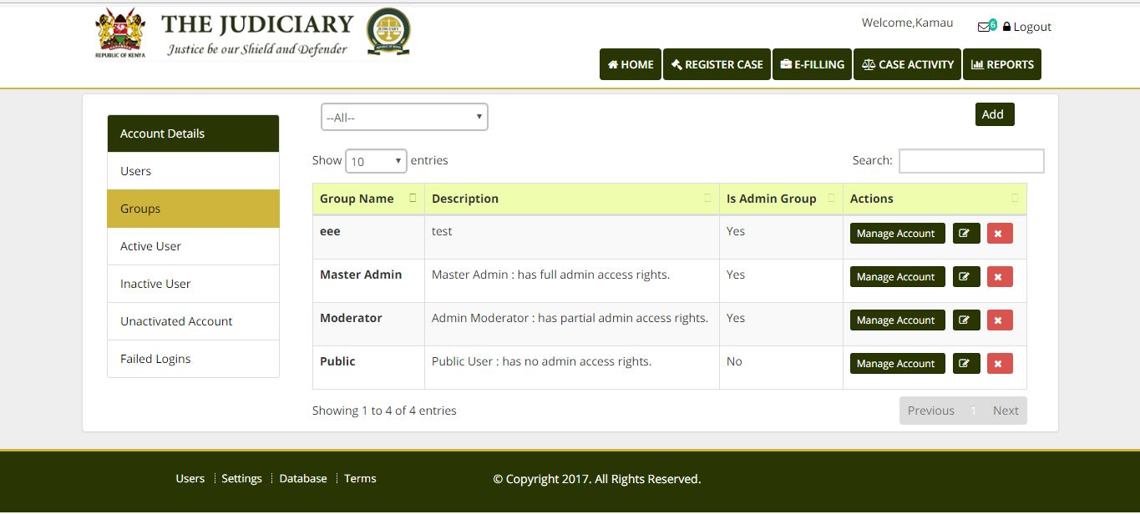

#### Manage general user group with specific privileges

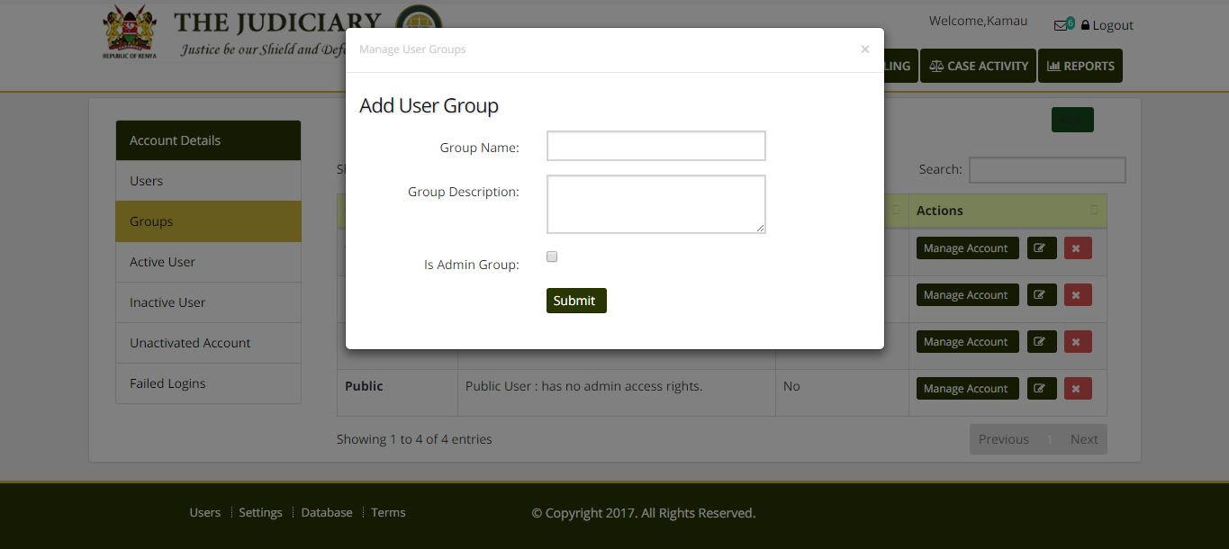

#### Add user groups

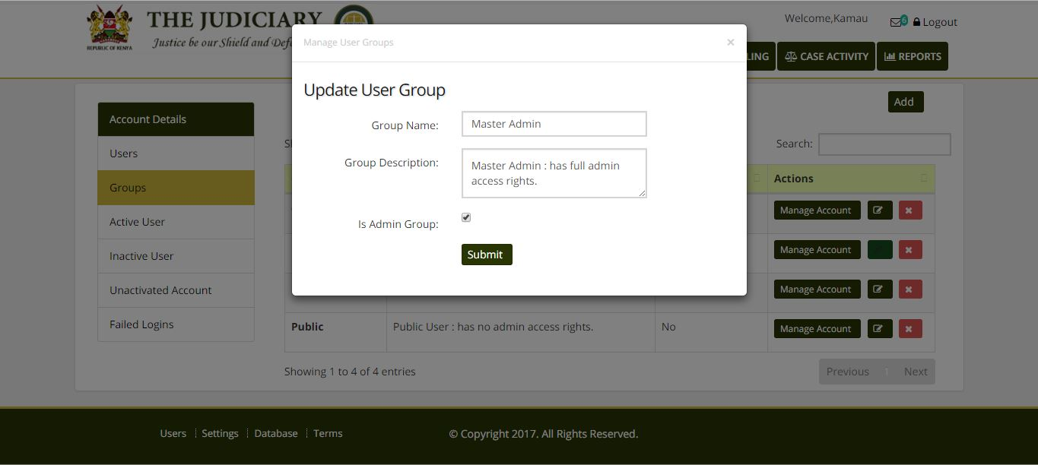Edit users groups

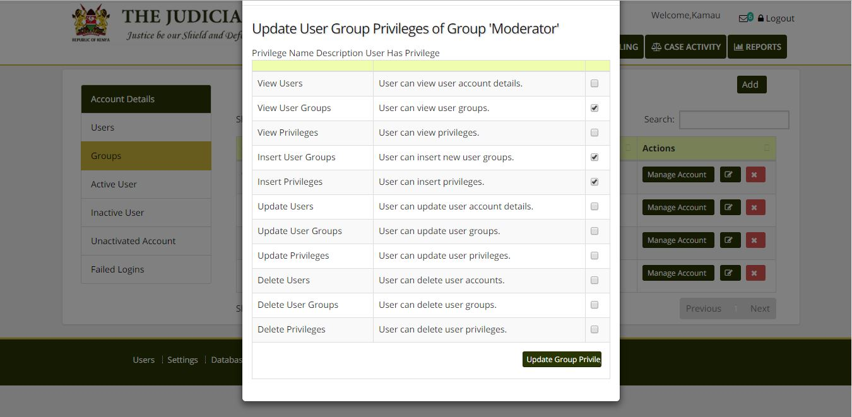

#### Add or revoke specific user privileges

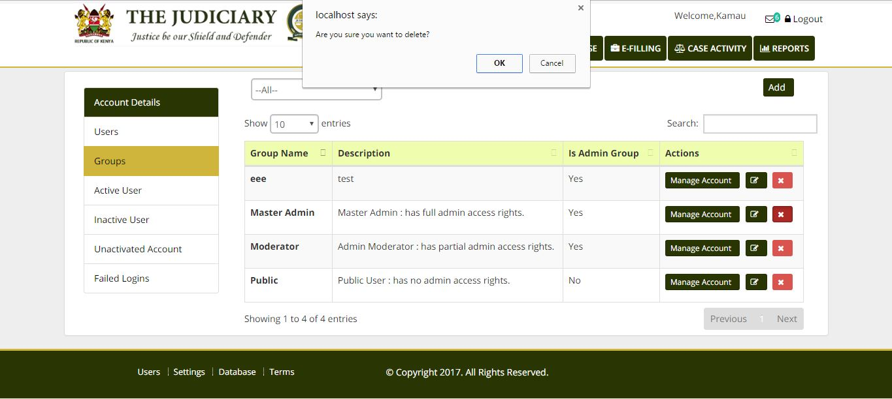

#### Suspect a specific group of privileges

#### USERS ACTIVITIES

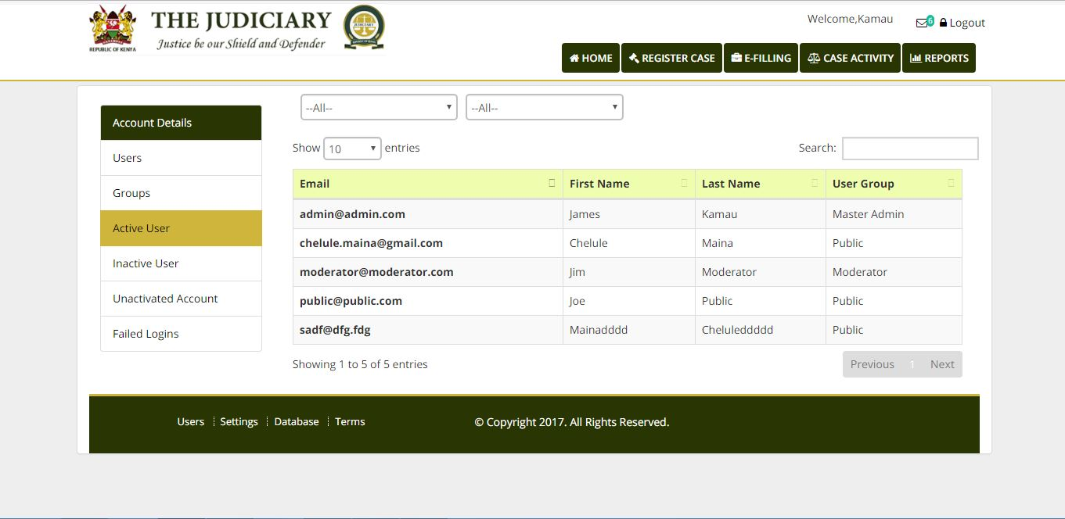

#### List of active user

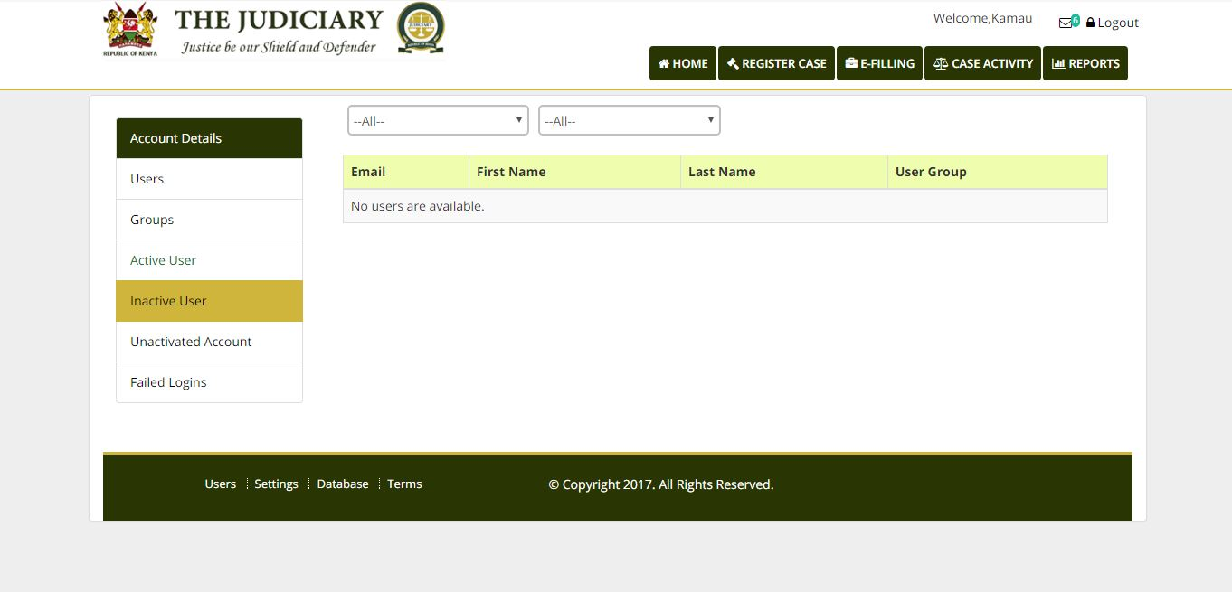

#### List of inactive users

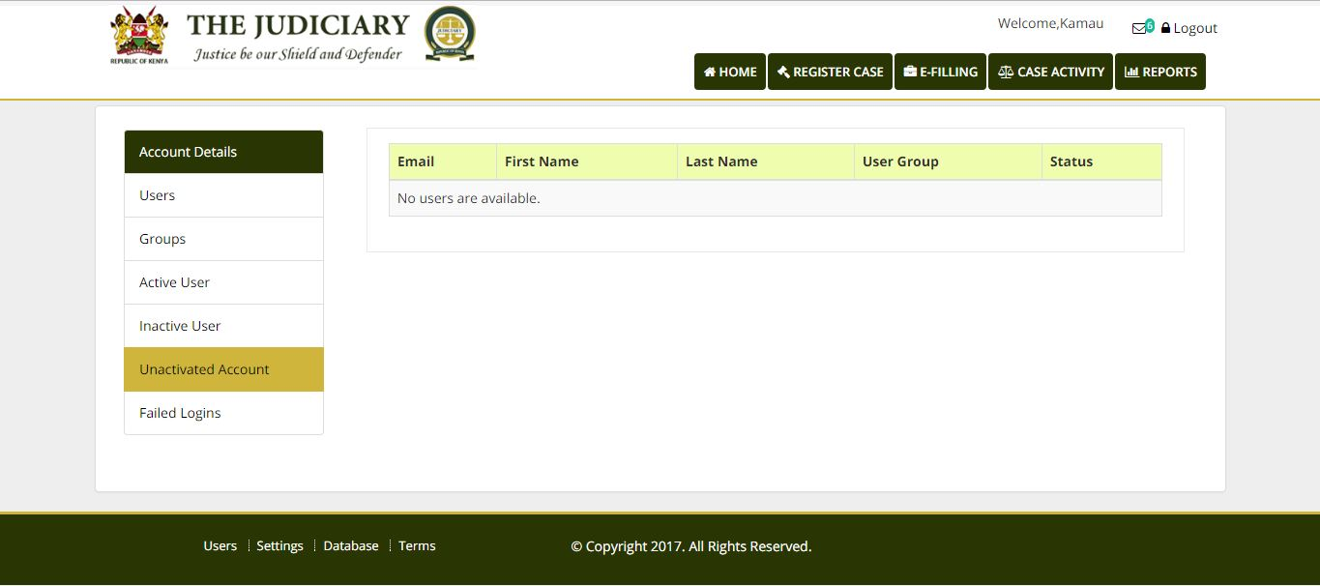

#### List of user whose account have not been activated or their account have been suspended

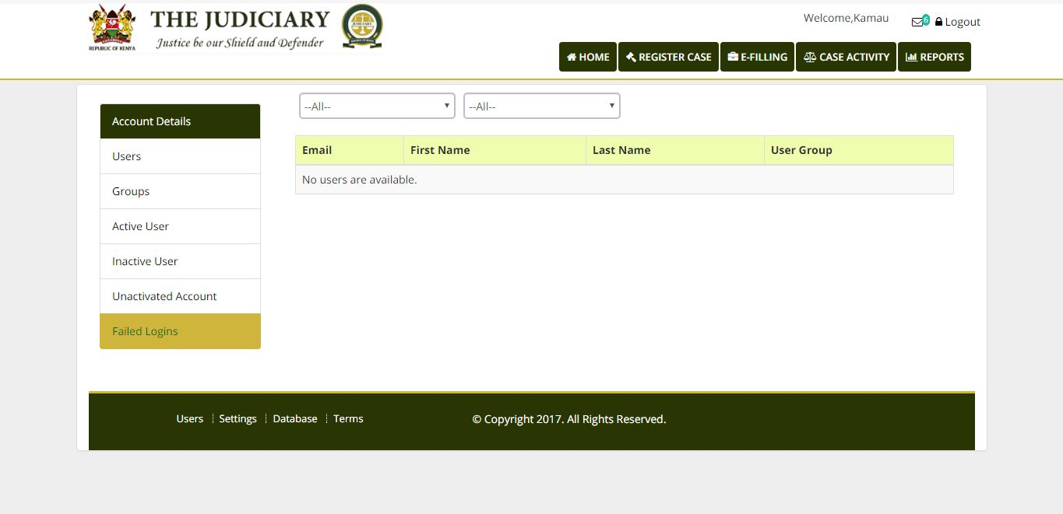

#### SETTINGS

Before any the system is used, valid data must be present. This includes **Courts, Divisions, ranks, Case categories, case types**, etc. This therefore means that a page for setting each one must be establish

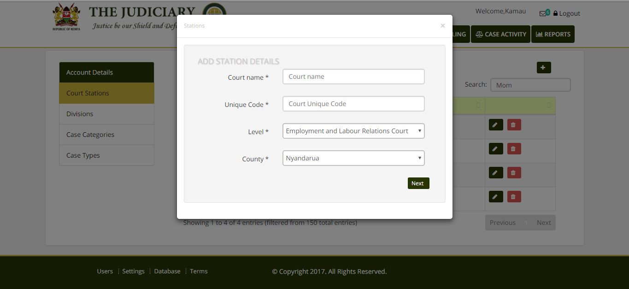

#### Add new court stations

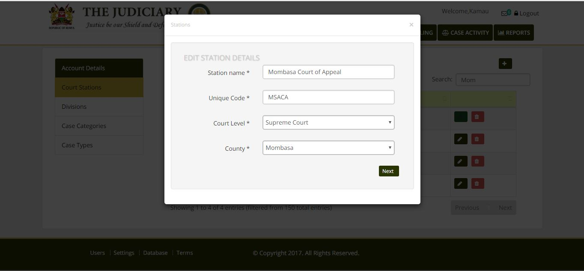

#### Edit court stations Name, locations and level

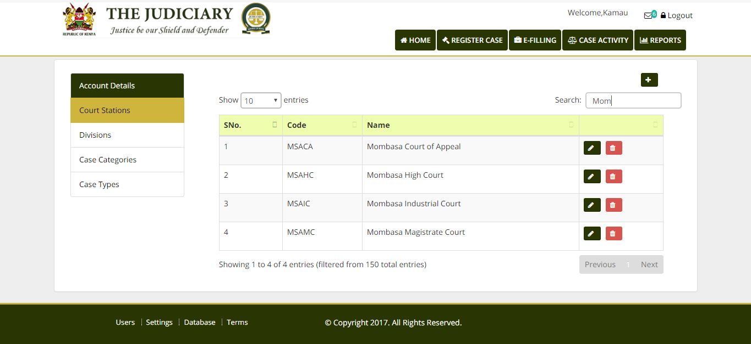

#### Search court stations to enable editing of review

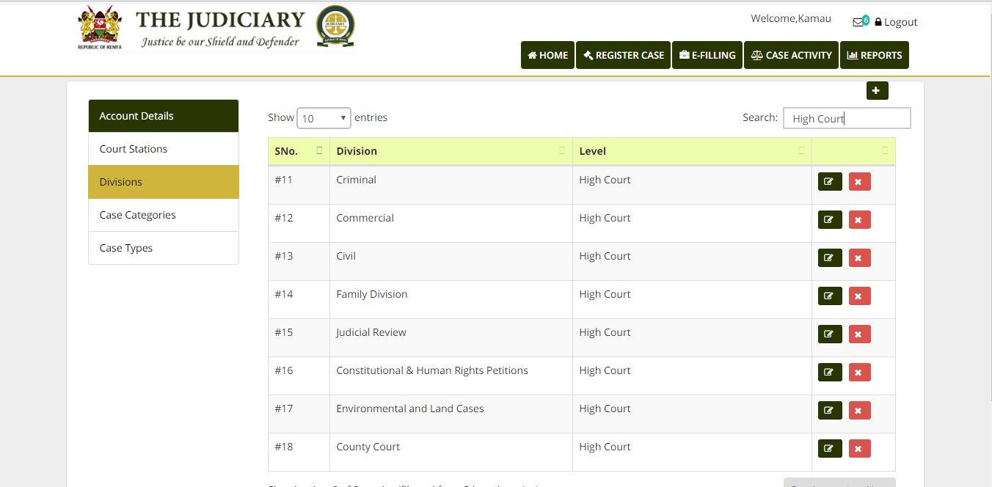

## Court division page, which allows edit, delete or add;

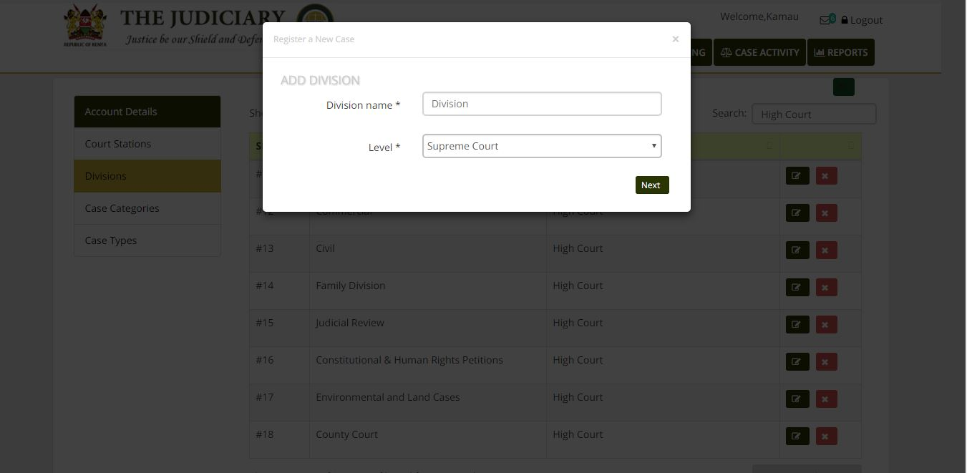

#### Add court Division

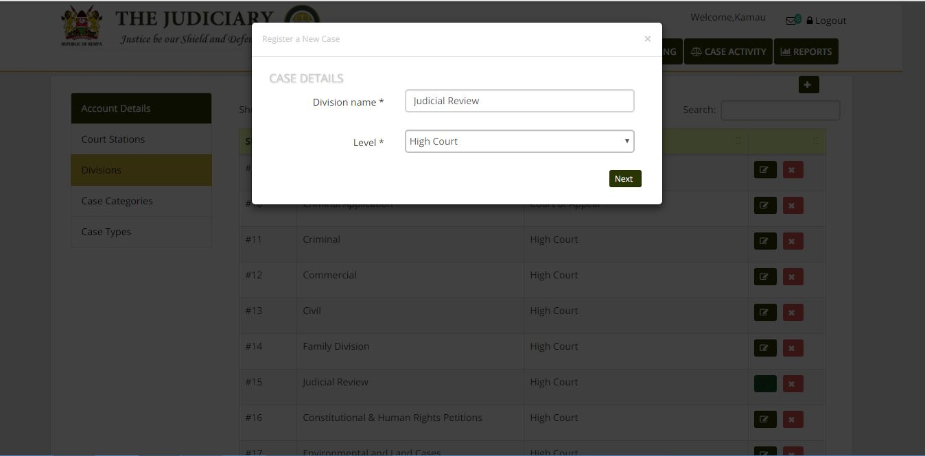

#### Edit court division

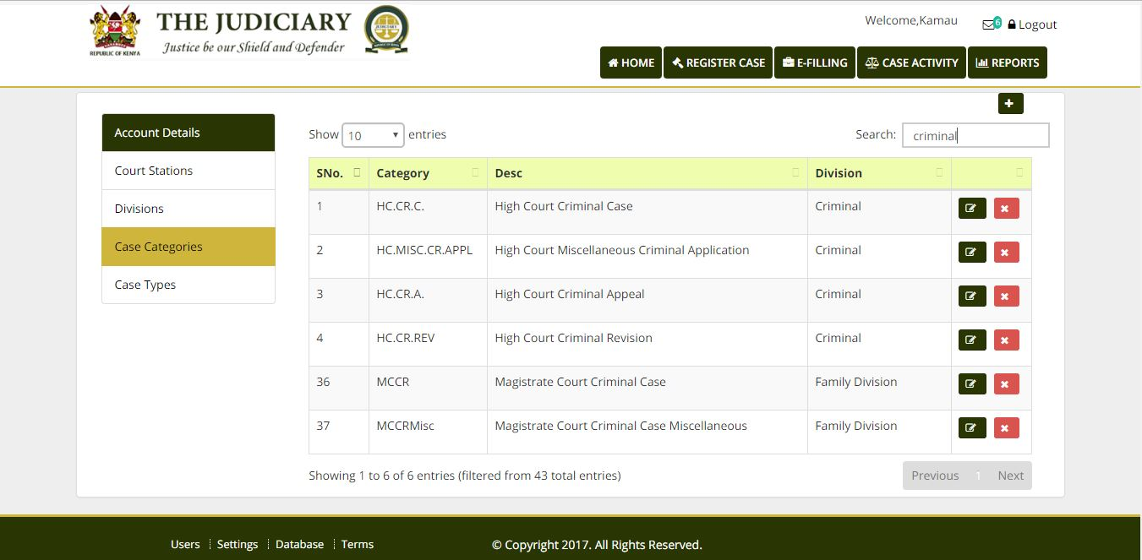

### Case Details

If a case exists, the user proceeds to the view case details tab.

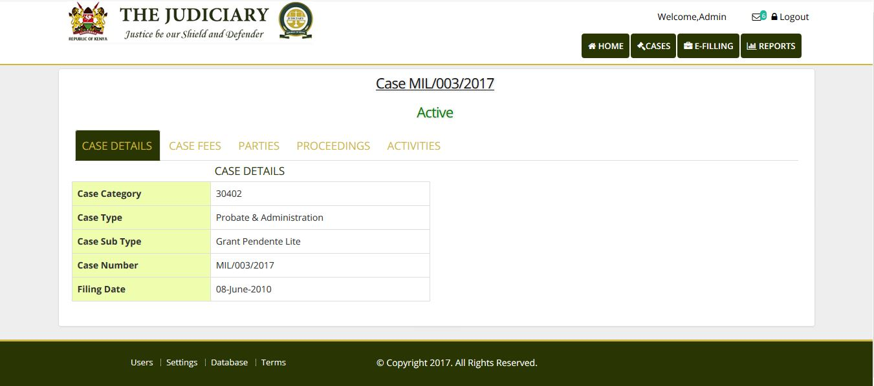

This page displays The case number for the selected case and the status is displayed in Green. On this tab Citation will be displayed and other case details. This page is yet to be modified.

#### Case Fees Tab

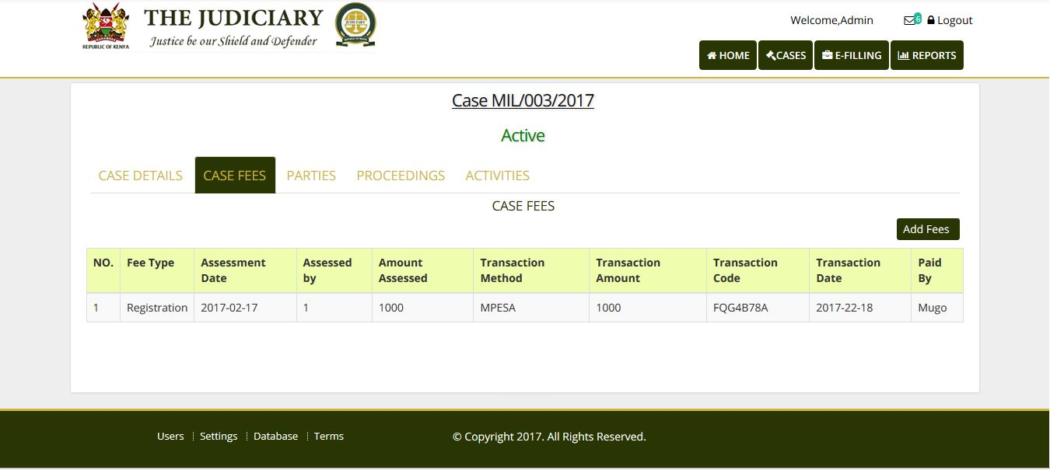

This Tab displays all fees associated with the selected Case. One can also add Fees to a case.

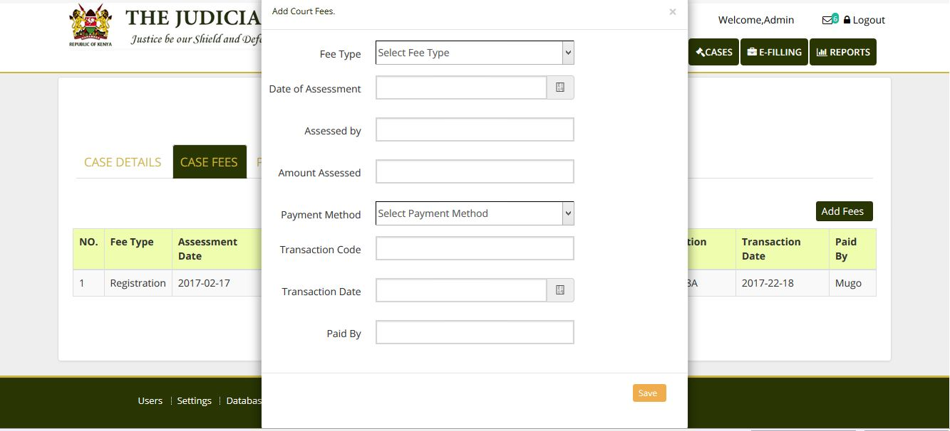

#### Case Parties Tab

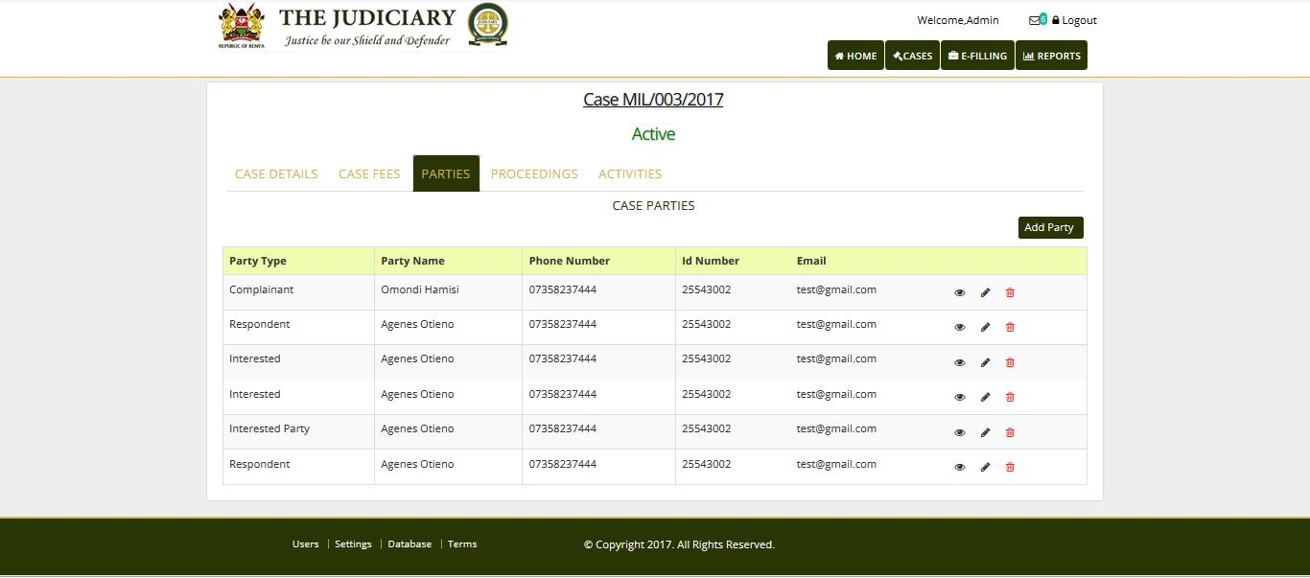

This tab lists the parties associated with the selected case. Parties can be added, edited.

**Proceedings Tab**

Not defined yet.

#### Activities Tab

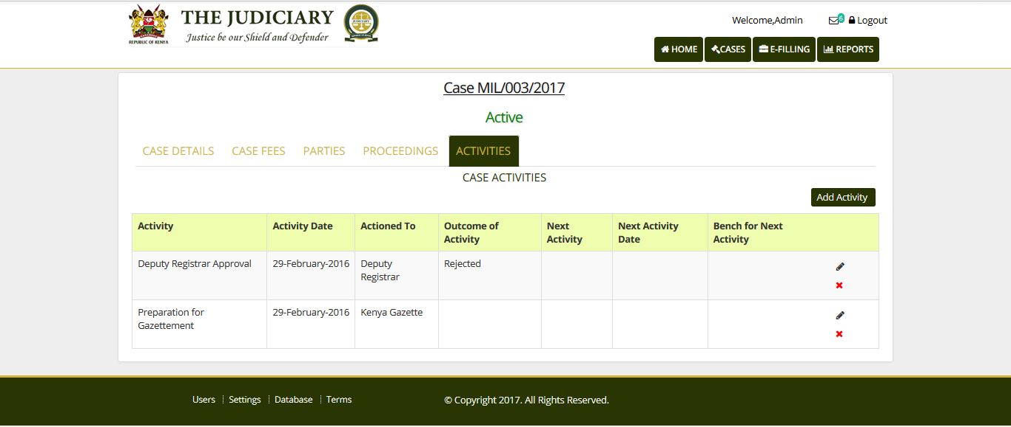

### User Management Appendix

|  |  |  |  |  |
| --- | --- | --- | --- | --- |
| **Module** | **Permission** | **Users** | **Role** | **scope** |
| Case Registration module | :create_case | Designated Court Registry Assistant | Case Registration officer | Per division |
| :view_case | All staff | Case Registration officer | Per division |
| :edit_update_case | Designated Court Registry Assistant | Case Registration | Per division |
| Court fees management module | :add_fee | Designated Accountant | Fees collection officer | Per division |
| :view_fee | all | Accountants | Per court |
| :remove_fee | Designated Accountant | Fees collection officer | Per court |
| :edit_update_fee | Designated Accountant | Fees collection officer | Per court |
| Document Management module | :add_document | Designated Court Registry Assistant | Case Registration officer | Per division |
| :edit_update_document_info | Designated Court Registry Assistant | Case Registration officer | Per division |
| :view_document | All |  | Per division |
| :remove_document | Designated Court Registry Assistant | Case Registration officer | Per division |
| Case tracking module | :create_file_movement | Designated Court Registry Assistant | Court Assistants | Per division |
| :update_file_movement | Designated Court Registry Assistant | Court Assistants | Per division |
| :view_movements | All |  | Per division |
| Case Empaneling and Calendaring (ediary) module | :add_activity | Designated Court Registry Assistant | Date Fixing Officer | Per division |
| :view_activity | All | All | Per division |
| :edit_update_activity | Designated Court Registry Assistant | Date Fixing Officer | Per division |
| :remove_activity | Designated Court Registry Assistant | Date Fixing Officer | Per division |
| :view_causelists | All |  | Per division |
| :take_out_matters | Designated Court Registry Assistant | Date Fixing Officer | Per division |
| :assign_matter_to_officer | Designated Court Registry Assistant | Date Fixing Officer | Per division |
| :reassign_matter | Designated Court Registry Assistant | Date Fixing Officer | Per division |
|  |  |  | Per division |
| Exhibits Management System module | :add_exhibit | Court Registry Assistant | Court assistant | Per division |
| :view_exhibit | All | Court assistant | Per division |
| :update_exhibit | Court Registry Assistant | Court assistant | Per division |
| Reports Module | :view_case_status_reports | EO , DR , RHC, J & MG , CRJ,DCJ, CJ | Management | Per court |
| :view_caseload_reports | EO , DR , RHC , J&MG,CRJ,DCJ, CJ | Management | Per court |
| :view_fees_reports | EO , DR , RHC , CRJ,DCJ, CJ | Management | Per court |
| :view_movements_reports | EO , DR , RHC , J&MG,CRJ,DCJ, CJ | Management | Per court |
| :view_issues_reports | EO , DR , RHC , J & MGCRJ,DCJ, CJ | Management | Per court |
| :view_rrds_reports | EO , DR , RHC , CRJ,DCJ, CJ | Management | Per court |
| :view_exhibit_reports | EO , DR , RHC , J &MG CRJ,DCJ, CJ | Management | Per court |
| Administration module |  |  |  |  |
| :create_court | ICTO | ICT admin | Per court |
| :create_court_division | ICTO | ICT admin | Per court |
| :assign_user_to_court_division | ICTO | ICT admin | Per court |
| :add_user | ICTO | ICT admin | Per court |
| :update_user_info | ICTO | ICT admin | Per court |
| :view_user_info | ICTO | ICT admin | Per court |
| :deactivate_user | ICTO | ICT admin | Per court |
| :add_role | ICTO | ICT admin | Per court |
| :rename_role | ICTO | ICT admin | Per court |
| :view_role | ICTO | ICT admin | Per court |
| :reassign_role_to_user | ICTO | ICT admin | Per court |
| :view_permission_reports | ICTO | ICT admin | Per court |
| :assign_permissions_to_user | ICTO | ICT admin | Per court |
| :add_judicial _officer | ICTO | ICT admin | Per court |
| :edit_update_judicial_officer_info | ICTO | ICT admin | Per court |
| :deactivate_judicial_officer | ICTO | ICT admin | Per court |
| :assign_division_to_officer | ICTO | ICT admin | Per court |
|  |  |  |  |

### Database Schema Appendix

